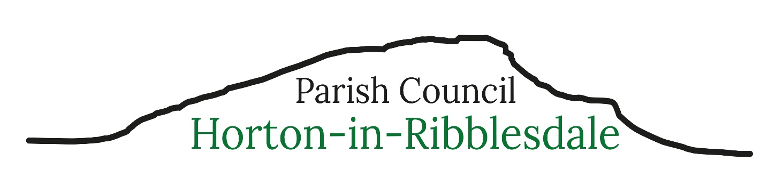
Parish Clerk – Michelle Park
clerk@hortoninribblesdale-pc.gov.uk Telephone 07469 584759
3rd August 2026
Dear Parishioner
You are invited to attend the next meeting of Horton-in-Ribblesdale Parish Council to be held in The Pavilion on Monday 10th August 2026 commencing at 7.30pm.
The public and press are invited to attend the meeting.
086/27: To receive apologies for absence.
087/27: To consider the approval of reasons for absence given by councillors.
088/27: Code of Conduct – Localism Act 2011.
a) To record any councillor’s disclosable pecuniary interests in relation to any item on this agenda. To receive any changes in members’ register of interests & declaration of interests forms and to receive, consider and decide upon any applications for dispensations.
b) To complete new Register of Interest Forms.
089/27: To confirm the minutes of the Parish Council Meeting held 13th July 26 as a true and accurate record.
090/27: Matters arising (not noted elsewhere on the agenda) – to receive information on the following on-going issues and decide further action where necessary.
1 – Highways – invited to attend meeting, no confirmation on attendance as at agenda date above
2 – Website and email services
3 – Defibrillator training
091/27: Public Participation – the period of time allocated for this item shall not exceed 15 minutes.
092/27: To consider and decide upon the following planning applications
- C/44/101K Full planning permission (Major with ES) for the extraction of further stone resources within the current planning boundary, reworking and steepening of the older south-west faces and haul routes to laterally expand and deepen the current quarry void, along with the extraction of remaining permitted minerals, mineral processing, stocking and export of products by rail and road, the export by rail of mineral imported from Dry Rigg Quarry and revised restoration and aftercare. Arcow Quarry, Helwith Bridge, Horton-in-Ribblesdale, (GR:380280,470540)
Application noted at the Parish Council meeting of the 13/7/26. Additional information received from Tarmac letter dated 21/7/26 and email correspondence of the 31/7/26.

- C/44/238G/LB Listed Building Greengates Farmhouse, Brackenbottom, Horton in Ribblesdale, BD24 0EU. Listed building consent for alterations to the front elevation of the attached outbuilding

093/27: North Yorkshire Council Reports - NYCC Cllr. Staveley 094/27: Financial Matters
- To receive and note the current bank account balances as at 31.7.26
HSBC Current Account £11,673.60
HSBC Savings Account £6,523.46
HSBC Dinsdale Account £3,295.91
- To receive and note the bank reconciliation and the payments made in July 26.
- To note progress with changing the HSBC bank mandate signatories
- Approval of Clerk’s administration and additional hours expenses
- Work from Home Allowance approval
095/27: Training and Development: to consider training opportunities and attending other local council meetings
096/27: Green Space:
097/27: Highways, Parking, Footway Lighting &Maintenance:
- Blocked drainage
098/27: Correspondence:
- YDNP Local Plan 2025-40 adopted
- NYCC Listed Asset of Community Value Playing Fields
- Email regarding quarry traffic speed
- Email regarding increased traffic in the village
099/27: Reported Incidents to North Yorkshire Police:
100/27: To resolve to exclude members of the public and press under the Public Bodies (Admissions to Meetings) Act 1960 due to the nature of the business to be transacted at items 100/27 to being prejudicial to the public interest
- Appointment of Internal Auditor for 26/27
- Grass cutting
101/27: To determine any Matters not included on the agenda which the Chair considers to be a matter of urgency
102/27: The Date of The Next Parish Council Meeting: Monday 14th September 7.30pm at the Pavillon , Horton in Ribblesdale

Michelle Park
Michelle Park - Parish Clerk & RFO

