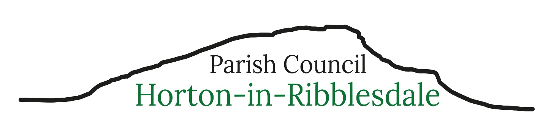Parish Clerk – Michelle Park
clerk@hortoninribblesdale-pc.gov.uk Telephone 07469 584759
7th July 2026
Dear Parishioner
You are invited to attend the next meeting of Horton-in-Ribblesdale Parish Council to be held in The Pavilion on Monday 13th July 2026 commencing at 7.30pm. The public and press are invited to attend the meeting.
067/27: To receive apologies for absence.
068/27: To consider the approval of reasons for absence given by councillors.
069/27: Code of Conduct – Localism Act 2011. To record any councillor’s disclosable pecuniary interests in relation to any item on this agenda. To receive any changes in members’ register of interests & declaration of interests forms and to receive, consider and decide upon any applications for dispensations.
070/27: To confirm the minutes of the Parish Council Meeting held 8th June 2026 as a true and accurate record.
071/27: Matters arising (not noted elsewhere on the agenda) – to receive information on the following on-going issues and decide further action where necessary.
1 – Highways - previous public discussion (no NYCC attendee)
2 – Planning follow up – Holme Farm Car Park
3 – Defibrillator repayment
4 – Emergency Plan
072/27: Public Participation
073/27: To consider and decide upon the following planning applications
C/44/101K Full planning permission (Major with ES) for the extraction of further stone resources within the current planning boundary, reworking and steepening of the older south-west faces and haul routes to laterally expand and deepen the current quarry void, along with the extraction of remaining permitted minerals, mineral processing, stocking and export of products by rail and road, the export by rail of mineral imported from Dry Rigg Quarry and revised restoration and aftercare
074/27: North Yorkshire Council Reports - NYCC Cllr. Staveley
075/27: Financial Matters
- To receive and note the current bank account balances as at 30.6.26
HSBC Current Account £14,204.71
HSBC Savings Account £6,516.60
HSBC Dinsdale Account £3,292.45
- To receive and note the bank reconciliation and the payments made in June 26
- To receive and note the budget comparison as at 30.6.26
- To approve the outstanding invoices for payment
- To consider and approve the updated Financial Regulations (version March 2025)
- To consider and approve the financial payment process – including new HSBC bank signatories
- Website and email services – consider and approve virement of funds into IT budget
- Protect the Peaks Girlguiding Campaign – consider and approve a grant/support
076/27: Council Policies – to receive and consider the schedule of council policies and approve an action plan to address any gaps
077/27: Training and Development – to receive a copy of the NALC Good Councillor Guide
078/27: Burial Ground Fees Review – to receive and consider current fees
079/27: Green Space:
080/27: Highways, Parking, Footway Lighting &Maintenance:
081/27: Correspondence: Calderdale Energy Park
082/27: Reported Incidents to North Yorkshire Police:
083/27: Employment matters -
- To note the Council will need to register with The Pensions Regulator
- To receive and consider the payroll administration costs
- To consider and approve the Standing Orders relating to employee management (p24) – 3 Councillors required for a HR committee
- To consider and approve the training costs for the ILCA and FILCA courses
- To resolve to exclude members of the public and press under the Public Bodies (Admissions to Meetings) Act 1960 due to the nature of the business to be transacted at items 083/27 (5) and (6) to being prejudicial to the public interest
- To note and approve the employment contract
- To receive and consider employee entry into a pension scheme
084/27: To determine any Matters not included on the agenda which the Chair considers to be a matter of urgency 085/27: The Date of The Next Parish Council Meeting: Monday 10th August 7.30pm at the Pavillon , Horton in Ribblesdale
Michelle Park, Parish Clerk

